Karma Coordinates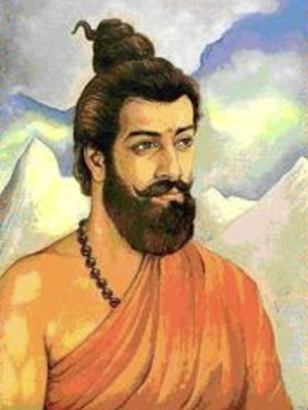

According to Sankhya-yoga Prakriti (the universe) exists for providing experiences to Purush. Purush upon realization that “I exist” is liberated (Moksha). Every life form in Prakriti is engaged in providing experiences to a Purush. Once all Purush are awakened, the Prakriti’s work is complete and it collapses into a singularity and the next cycle is started with a big-bang.   
  
As per the open model with omega of 6, universe is 6 billion years old and it will end when it is about 13 billion years old. That is in another 7 billion years. (https://en.wikipedia.org/wiki/Ultimate_fate_of_the_universe)

A life form comes into an existence due to a microscopic particle in nature called as Sukshm. Human life is the only known form of Sukshm that is capable of achieving Moksha for its Purush.

Sankhya-yoga quantifies and explains attributes (Gunas) and tendencies (Bhavas) that can take a life form closer to achieving Moksha.

Karma Coordinates is a fun app developed to approximate based on your Gunas and Bhavas your current position in this karmic journey of many lives until Moksha.

A score of 5 billion years, means you are already at about 11 billion year mark - very near to achieving the awakening state. A score of 1 billion years means you are at 7 billion year mark, a little bit ahead but can speed it up by certain lifestyle based changes.

Karma Coordinates outcome is also explained in terms of three Gunas - Satva, Rajas and Tamas:

Satva is the light (Prakash) property in the Prakriti. The neural network in our brain - our intellect - has the highest Satva and lowest Tamas content.

Rajas is the energy property in the Prakriti. It moves mass. It activates. Our mind and bodies are enabled by Rajas.

Tamas is the mass property in the Prakriti - The flesh and bones of our body has highest Tamas and low Satva content.

| Satva | Rajas | Tamas |
| --- | --- | --- |
| High | High | Low |
| Medium | Medium | Medium |
| Low | Low | High |

Although the output is generated by Karma Coordinates AI, we encourage users to provide feedback based on their belief of how the three Gunas constitute and govern their bodies. The feedback will further refine the Karma Coordinates classification system.